

Produkt:

Doc-Nr:

Dateiname: NuvoControl_8600_SetupGuideNuvoControl.docx

Verantwortlich:

Ausgabe:

Datum:

1 GENERAL 3

1.1 Änderungen gegenüber der Vorgängerausgabe 3

1.2 Zweck 3

1.3 Anwendungs- / Geltungsbereich 3

1.4 Referenzierte Dokumente 3

1.5 Abkürzungen + Konventionen 3

**ABBILDUNGSVERZEICHNIS**

The picture on the front page is from <http://www.freedigitalphotos.net/>

GENERAL

## Änderungen gegenüber der Vorgängerausgabe

|  |  |  |  |
| --- | --- | --- | --- |
| **Index** | **Datum** | **Verantwortlich** | **Änderungen** |
| a | 21-Aug-2009 | Ch.Imfeld | Ändere Titelbild, Free Picture from <http://www.freedigitalphotos.net/> |
| b |  |  |  |

## Zweck

Dieses Dokument erklärt die Installation von NuvoControl auf einem Windows Rechner.

## Anwendungs- / Geltungsbereich

Dieses Dokument gilt für das NuvoControl Projekt.

## Referenzierte Dokumente

|  |  |  |
| --- | --- | --- |
| **Ref.** | **Dokument-Nr** | **Titel** |
|  | NuvoControl_0103 | Projekt Glossary, enthält Projektweite Abkürzungen (zusätzlich zu den im nächsten Abschnitt aufgeführten Abkürzungen spezifisch für dieses Dokument) |
| **[2]** |  |  |

## Abkürzungen + Konventionen

Liste von Abkürzungen spezifisch für dieses Dokument. Die globalen Projektweiten Definitionen sind in [1] aufgeführt.

|  |  |
| --- | --- |
| **Abkürzung** | **Beschreibung** |
|  |  |
|  |  |
|  |  |

Unvollständige oder noch zu vervollständigende Teile dieses Dokumentes sind in Spitzklammern ‘<’ . . . ‘>’ gekennzeichnet. Die Zeichenfolge‘**TBD**’ (to be defined) wird dabei zu Beginn der Spitzklammern gesetzt.

**Installation and Setup of NuvoControl**

The following screens describe the installation and setup process for NuvoControl.

* To start the installation, execute the *setup.exe*

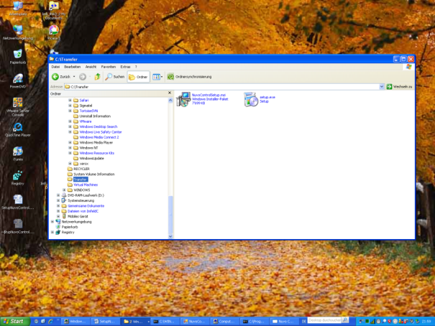

* The setup process starts ….
* The setup detects automatically missing components and ask to install them before the installation of NuvoControl
* Accept these additional components, otherwise NuvoControl is not runnable

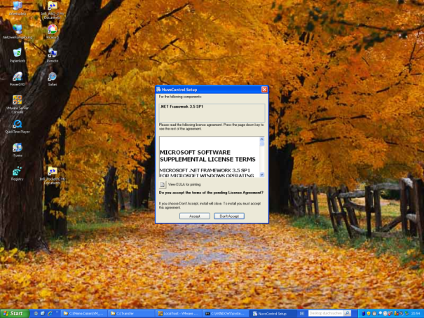

* The installation of the additional components has started

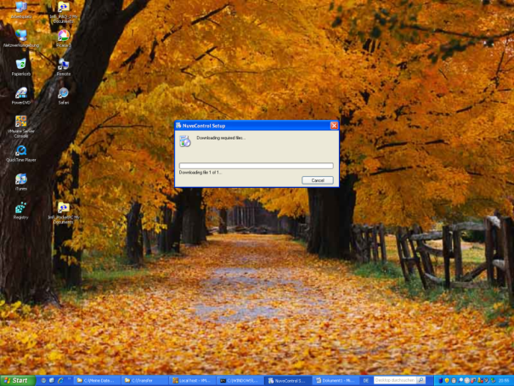

* The installation is on-going … ☺
* Please consider, that depending on the type of additional components which needs to be installed, the setup process can take very long. Especially the installation of the .NET Framework 3.5 took very long.

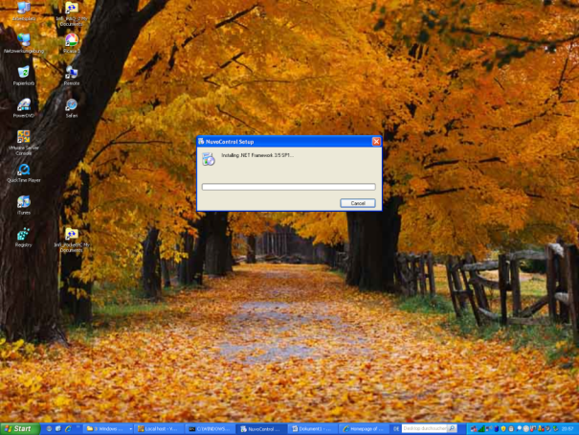

* Depending on the installed components, you may need to reboot the machine
* Press *Yes* to reboot

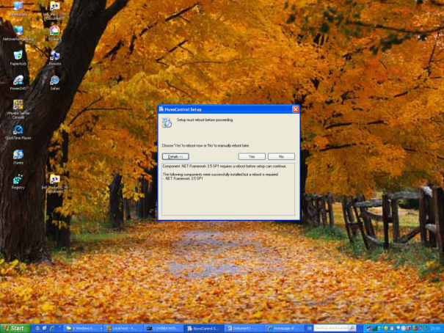

* After rebooting the machine, the setup is starting automatically and continues with the installation of NuvoControl

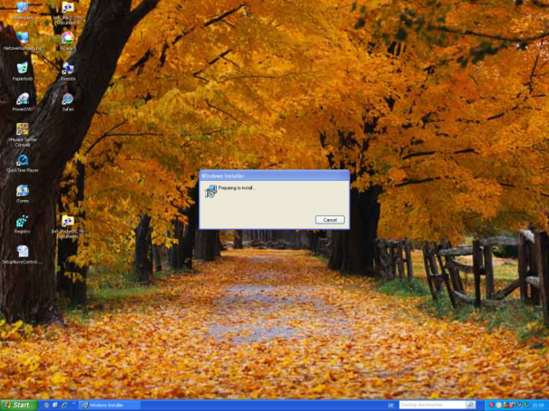

* First the welcome screen is displayed.
* Press *Next>* to continue

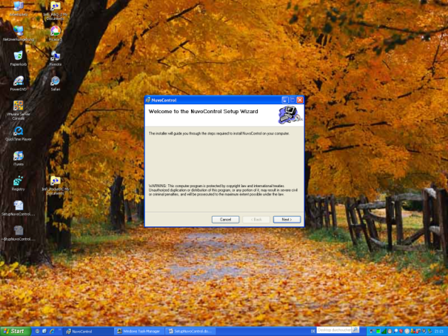

* The Installation Folder screen is displayed
* Select a comfortable destination folder to install NuvoControl
* Select the option if you want to install NuvoControl for everyone on this machine or just for the current user.
* Press *Next>* to continue

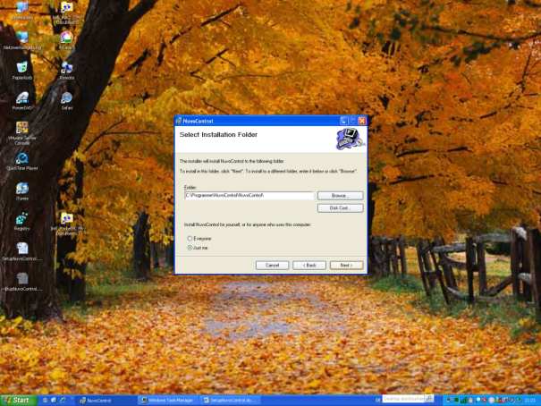

* The Confirmation screen is displayed
* Select *Next>* to continue

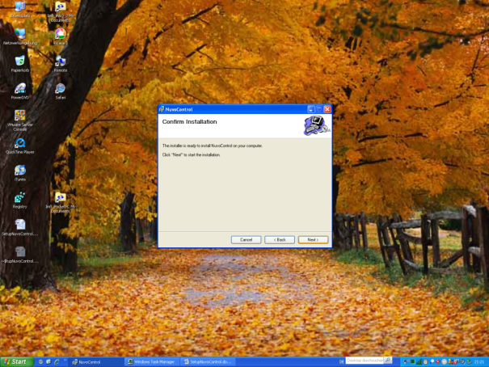

* The installation of NuvoControl is running. Please wait.

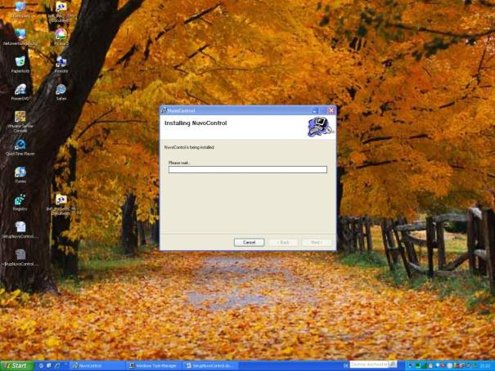

* After a few minutes the installation complete screen is displayed
* Press *Close* to finish the installation

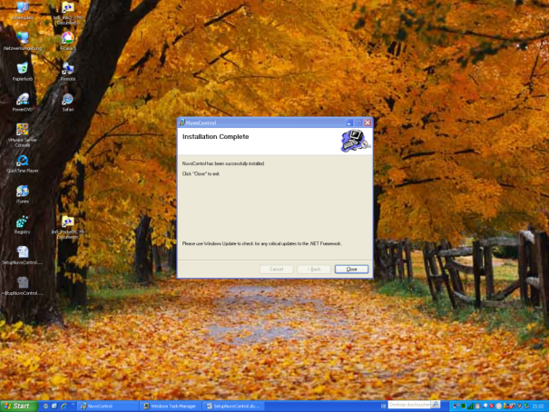

**Installation of additional windows components (like MSMQ)**

Depending on your machine you may need to install additional components. Mostly the Messaging Queue system is not installed per default.  
Please consider that you require the windows operating system CD to install this additional component.

* Open the windows setup window, via “Start” -> “Control Panel” -> “Add or Remove Programs”. Select the option “Add/Remove Windows Components”.
* Search the ‘Messaging Queuing’ entry and select the check-box
* Press *Details…* and select all options in the Message Queuing dialog box
* Press *OK* to close this dialog box
* Press *Next>* (*Weiter>*) to start the installation

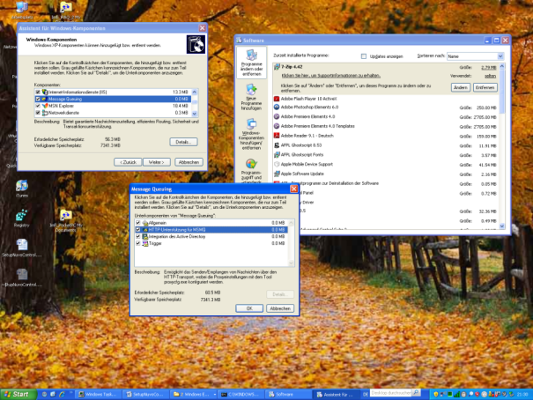

* The installation starts ….

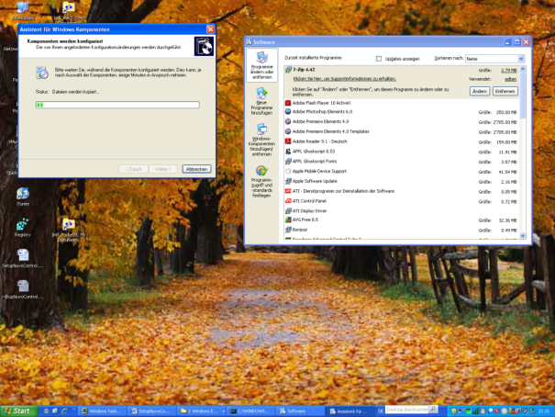

* You may be asked to insert the windows operating system CD
* Insert the CD
* Press *Ok* to continue

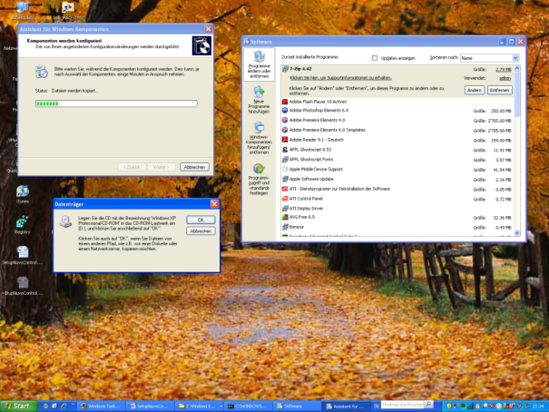

* The installation is continuing …

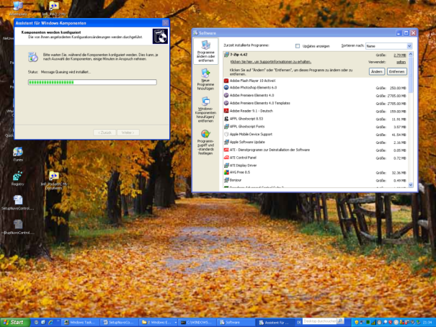

* Press *Finish* (*Fertig stellen*) to finish the installation

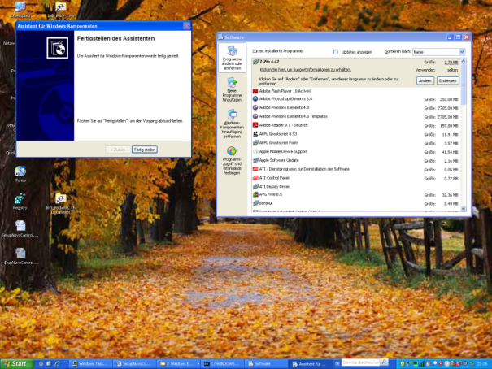

**Start the Simulator**

To test the installation, the best way is to start the simulator. For this tool no special configuration is required, it just needs the queuing system.

* To start the simulator use the entry in the start menu, or execute the NuvoControl.Server.Simulator.exe in the bin folder.
* The following screen should show up
* To start with the simulation, select *AllOk* as simulation mode. This mode answers to each request with a valid reply.

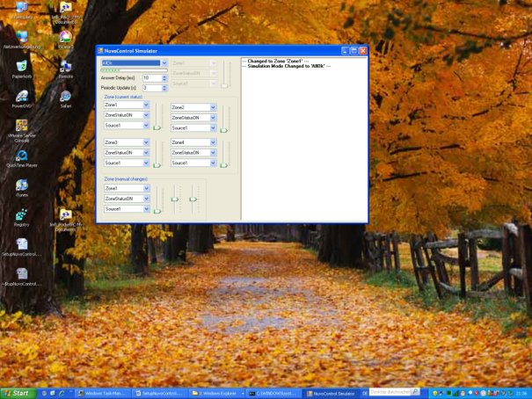

* Congratulation the installation of NuvoControl is mainly done
* With the computer management console you can verify that the required queues have been created at simulator start.
* You should see at least two queues. One with the name fromnuvoessentia and one with the name tonuvoessentia

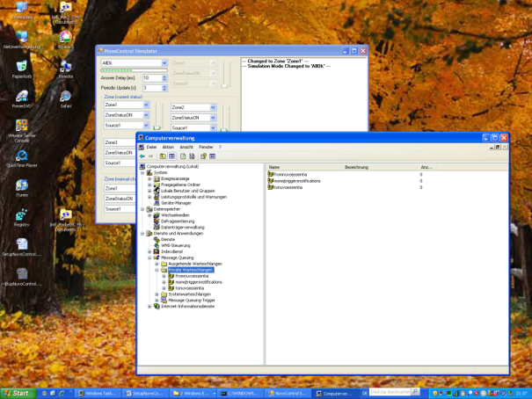

**Configuration of the Server Console**

The current setup doesn’t edit the configuration files. Per default the configuration should work and no changes are required. It should run out-of-the-box.

If not …   
You need to edit manually the XML configuration for each executable.

* Search for the files with the suffix *.config*. These are the configuration files for each executable.
* One setting in these files is the location of the NuvoControl configuration file. Specify the correct path and filename.
* Per default a standard configuration is delivered with the setup. In this case use .\NuvoControlKonfiguration.xml, because the standard configuration file is in the same folder as the executables.
* Save and close the configuration files

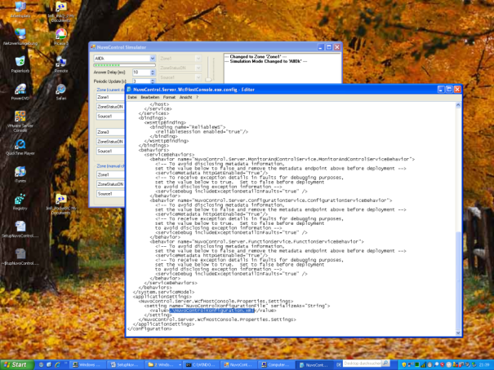

**Start of the server console**

The server console is used to start the server processes required for NuvoControl.

* To start the server use the entry in the start menu, or execute the NuvoControl.Server.WcfHostConsole.exe in the bin folder.
* The following screen should show up (in addition to the already running simulator).
* In the simulator you should see, that the server is sending commands and the simulator is returning – depending on its simulation mode – some data.

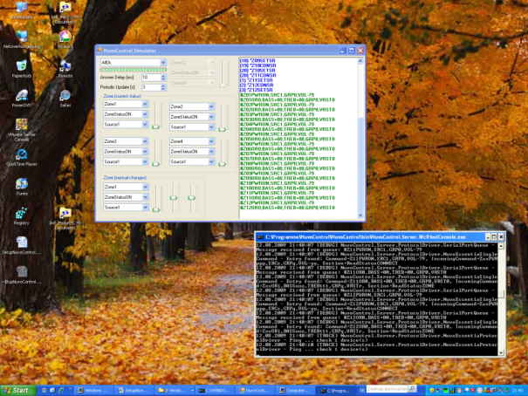

**Start of the viewer**

The viewer is the GUI to display the current system status and allows also changing the current selection.

* To start the viewer use the entry in the start menu, or execute the **NuvoControl.Client.Viewer.exe** in the bin folder.
* The following screen should show up (in addition to the already running simulator and server).
* In the simulator you should see, that the server is sending commands and the simulator is returning – depending on its simulation mode – some data.
* The viewer shows the standard configuration which is part of the setup.

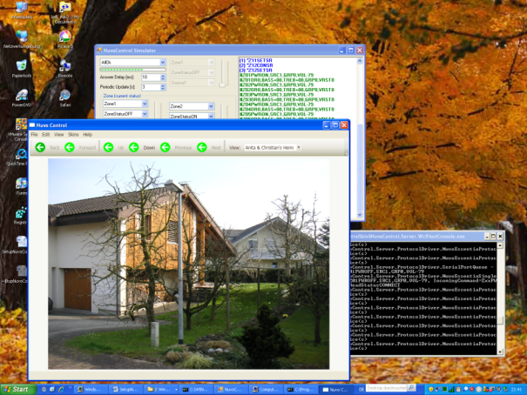

* Congratulation, you have successfully installed and setup the NuvoControl system
* With this three components can you ‘play’ around.

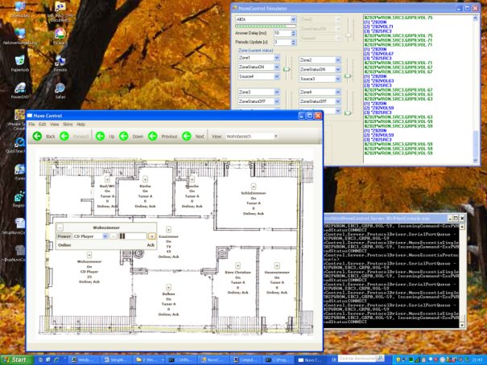

The next step would now be to configure the system according to your house, floors, rooms etc.

This is described in another section.